# Case Study Submission

# Ashutosh Gupta ,1209814

1. Name – Ashutosh Gupta
2. Employee ID – 1209814
3. Email ID- [ashutosh.gupta5@tcs.com](mailto:ashutosh.gupta5@tcs.com)
4. GIT Repository URL - <https://github.com/ashutosh21289/CaseStudyBootCamp.git>
5. Screen Shot of the docker file –

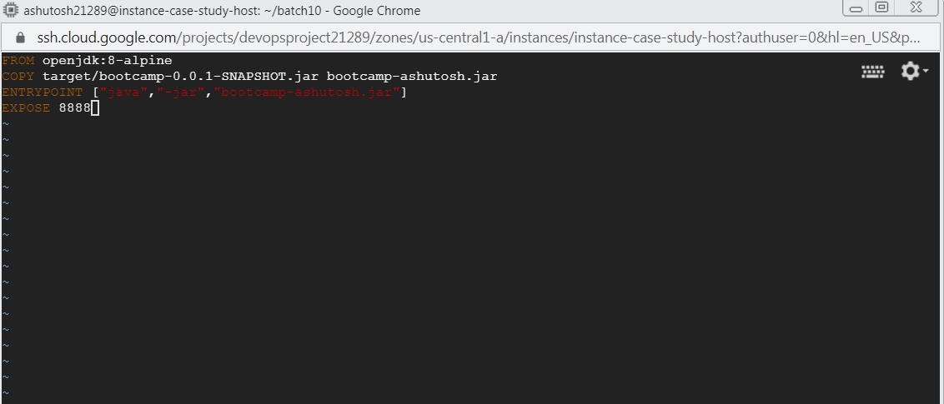

1. Screenshot Of Jenkins file –

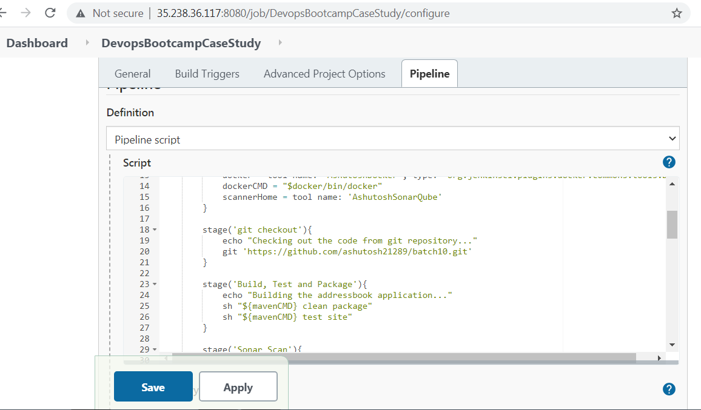

1. Jenkins Log File attached hereby and uploaded to github repository mentioned above.
2. Jenkins pipeline status

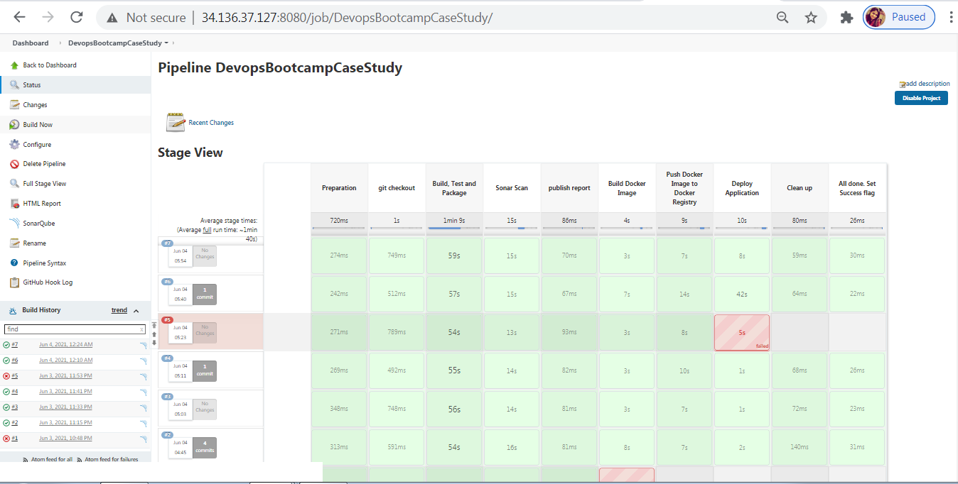

1. **Email Notification** –

Faced error below first instance and then turned on the dual factor authentication to enable

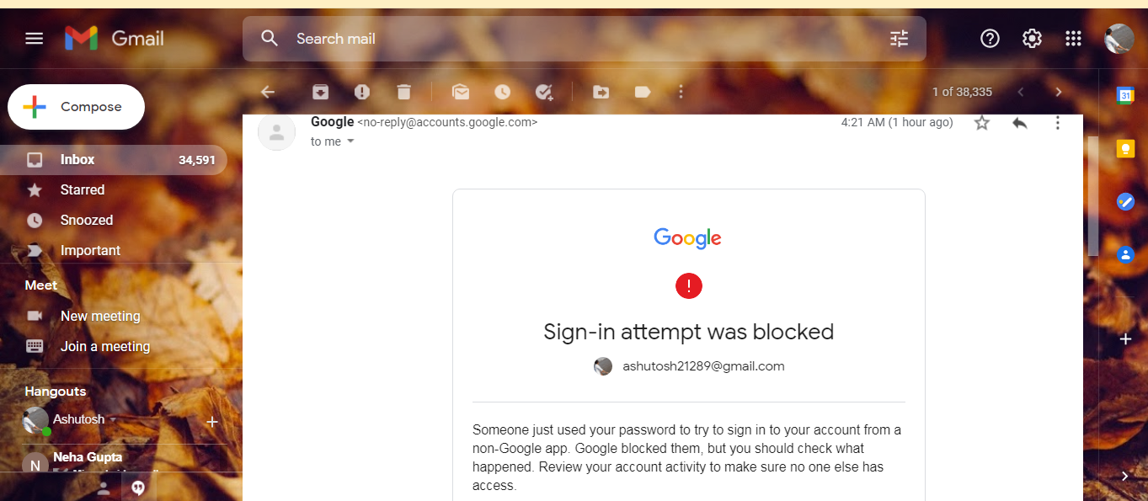

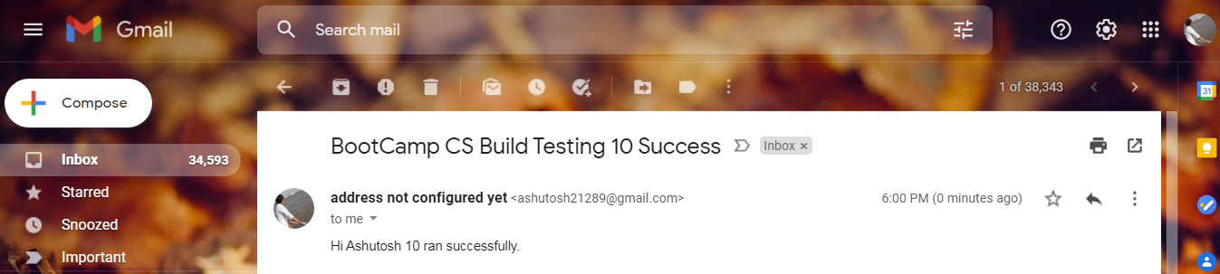

1. **Sonar Qube report** –

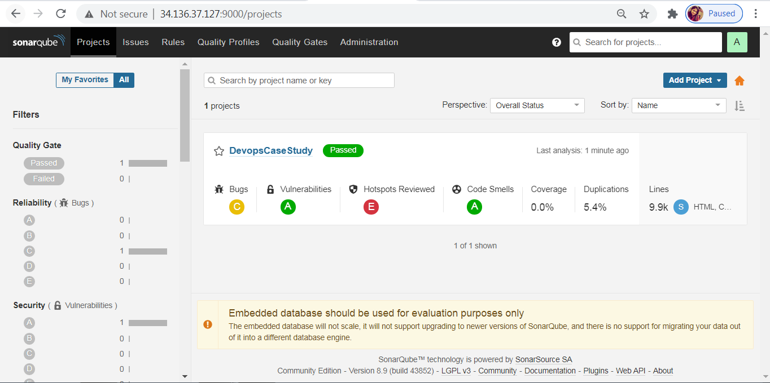

1. Ansible Playbook Execution

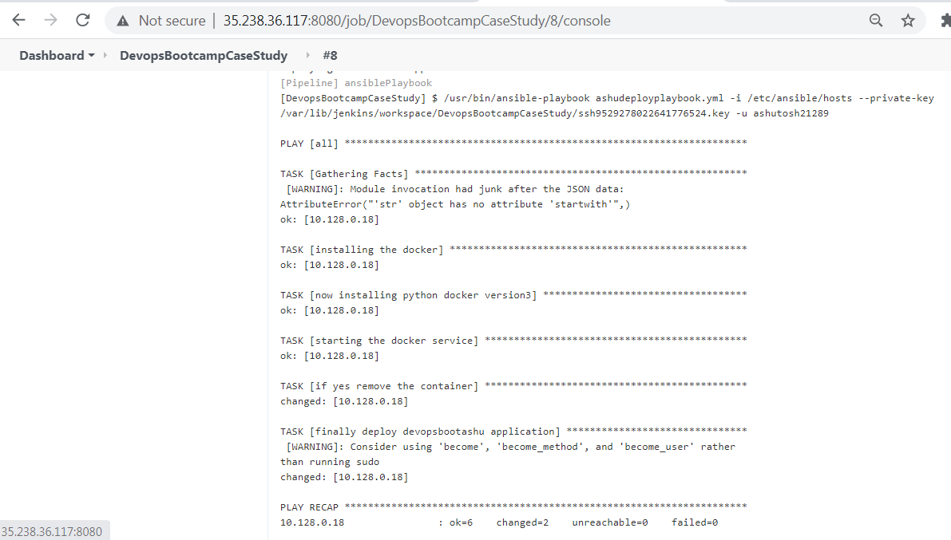

1. Working application launched

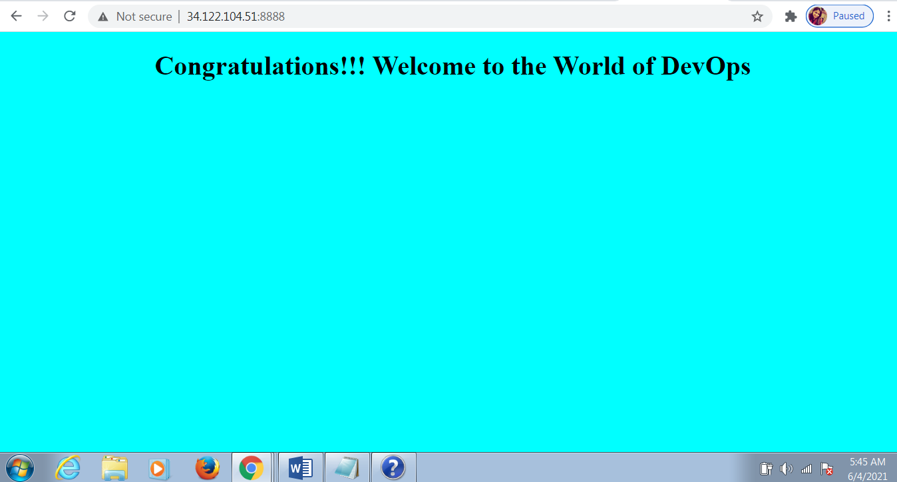

**Additional Artifacts**:

Below snapshots are for reference of above snapshots to show in detail processing.

**Instances for case study**

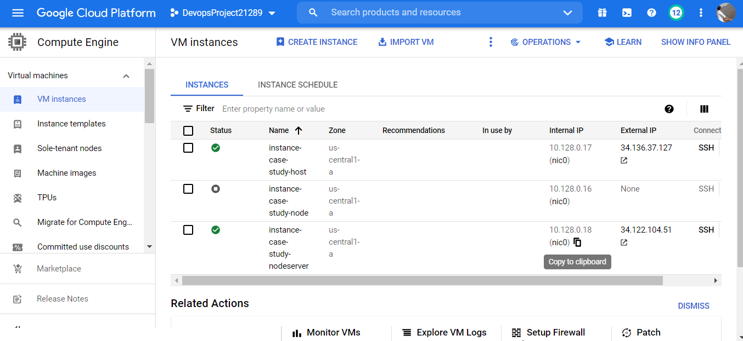

**JENKINS PLUGINS INSTALLED**

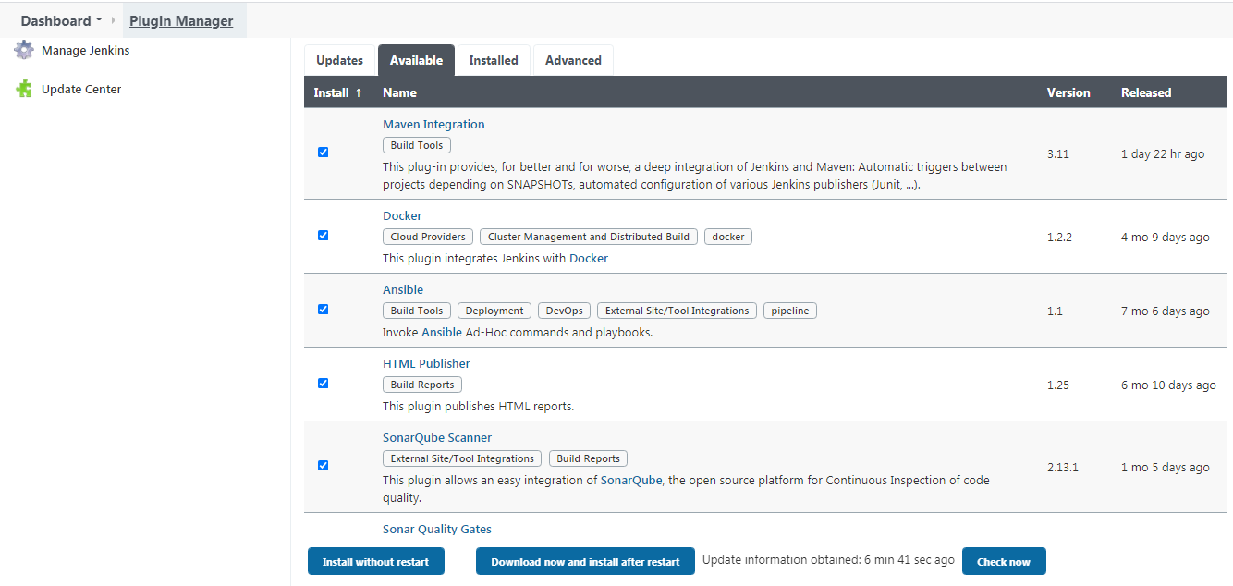

**WEBHOOKS IMPLEMENTED**

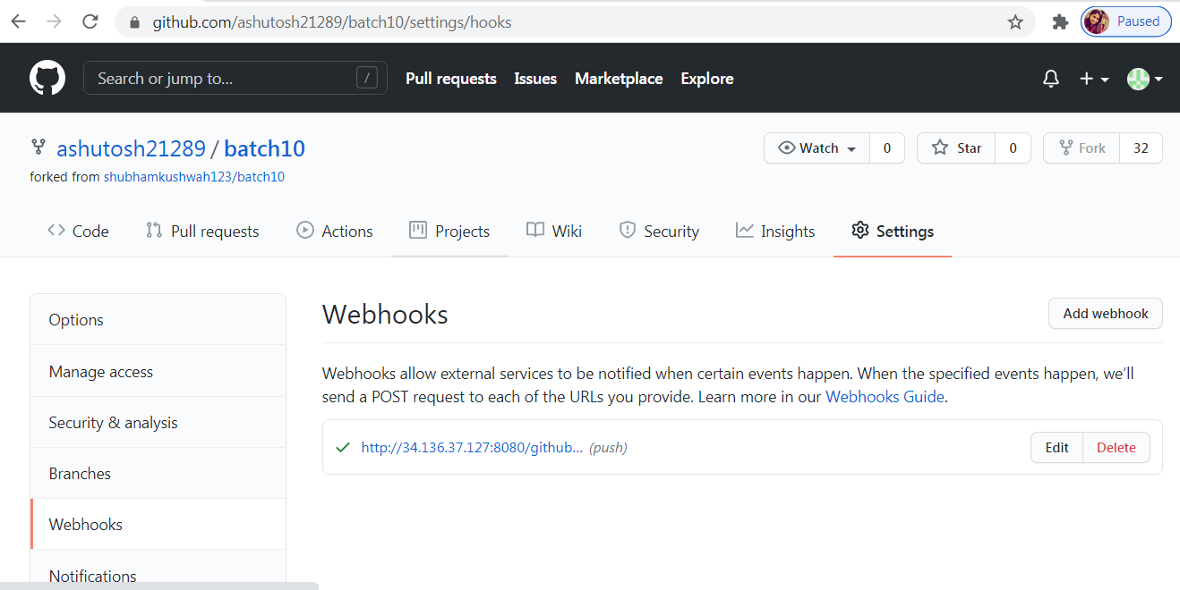

**PLAYBOOK**

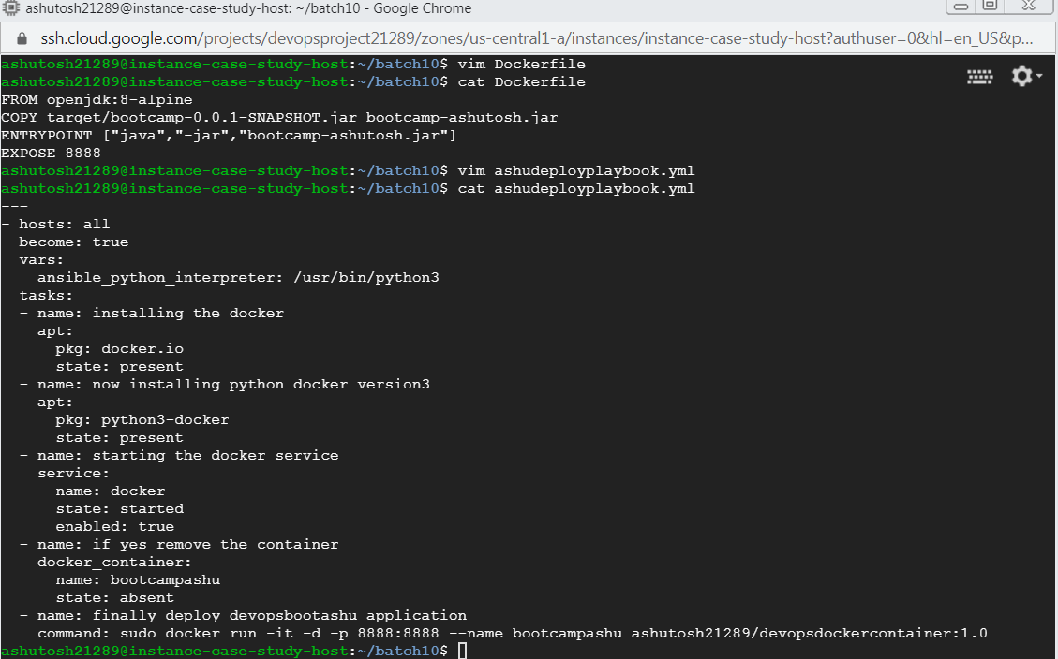

**CREATING SONAR TOKEN**

